

# ORIGAMI

**Supervisor:** *NGUYỄN HẠ VY*

**Semester:** *01*

**Batch No:** *T1.2208.A2*

**Group No:** *02*

|  |  |  |
| --- | --- | --- |
| **Order:** | **Full name** | **Roll No.** |
| *1.* | ***TRƯƠNG TẤN PHÁT*** | Student1409158 |
| *2.* | *NGUYỄN HOÀNG GIA PHÚC* | Student1396945 |
| *3.* | *NGUYỄN TRỌNG TIẾN ĐỨC* | Student1408029 |
| *4.* | *DIỆP THÁI THIÊN LONG* | Student1409154 |

***Month****: 11* ***Year****: 2022*

***Month****: 11* ***Year****: 2022*

This is to certify that

**Mr. TRƯƠNG TẤN PHÁT Mr. NGUYỄN HOÀNG GIA PHÚC Mr. NGUYỄN TRỌNG TIẾN ĐỨC**

**Mr. DIỆP THÁI THIÊN LONG**

Have successfully Designed & Developed

# ORIGAMI

Submitted by:

**Ms. NGUYEN VY**

Date Of Issue:

21/11/2022

Authorized Signature:

# Content

Content

Acknowledge Synopsis

Review 1

Review 2

Tasksheet ..

# Acknowledge

As we understand that the eProject is a step-by-step learning environment that closely simulates the classroom and Lab-based learning environment into actual implementation. It is a project implementation at your fingertips!! An electronic, live juncture on the machine that allows you to.

* Practice step by step i.e. laddered approach.
* Build a larger more robust application.
* Usage of certain utilities in applications designed by user.
* Single program to unified code leading to a complete application.
* Learn implementation of concepts in a phased manner.
* Enhance skills and add value.
* Work on real-life projects.
* Give a real-life scenario and help to create applications that are more complicated and useful.
* Mentoring through email support.

First of all, I would like to thank India Aptech for allowing my team to work on this fantastic eProject. We had a great experience with eProject this time.

Next, We would like to express my special thanks to our mentor, Ms. Ha Vy for the time and effort that she provided throughout the project. Your helpful advice and suggestions were beneficial to us during the completion of the project. In this respect, We are forever grateful to you.

Besides several mistakes we made in the project, we hope to have more opportunities to widen our knowledge in the web-developing world.

We will try to continue to learn and improve ourselves even more in the future.

Yours Sincerely, Team Group 02.

# Synopsis

The Objective of this program we aim is to give a sample project to work on real- life projects. These applications help us build a larger more robust application.

The objective is not to teach us HTML/JavaScript but to provide us with a real-life scenario and help us create basic applications using the tools.

Hence, we can revise the chapters before we start with the project.

This project is meant for students like us who have completed the module of HTML5. These programs should be done in the Lab sessions with the assistance of the faculty if required.

The website (in this project) is a tool that brings everything in the world to you such as historic monuments information natural knowledge and skill in technology...

It is very essential for us that will have a clear understanding of the subject. We think we should go through the project and solve the assignments as per the requirements given.

And get back [***eprojects@aptech.ac.in***](mailto:eprojects@aptech.ac.in) as the assigned schedule.

## Problem Definition

Origami originated from China and was popularized in Japan. It is the art of paper folding. Paper-folding is a wonderful hobby and a wonderful group activity... and for kids it has so many benefits socially and for the developing mind. You get to make cool stuff - with only a sheet of paper!

It's incredible to watch an ordinary piece of paper transforming into a three dimensional form, and the more complex the design, the more incredible this process becomes...

Origami can range from the super complex with realistic models to the simple models that are more easy to fold, but yet very recognizable.

Here we are aiming to design a website “OrigamiForAll” which will provide an easy way to learn origami with various designs and steps involved.

**Requirement Specification:**

The Web site is to be created based on the following requirements.

1. The home page must describe the keywords or highlight the origami designs with all navigation links defined.
2. The site should provide the brief information about origami as from where it originated etc.
3. There should be a well designed menu with necessary sub menu options.
4. There should be various categories (forms and styles) like easy for kids, complex for elders.
5. There should also be categories of designs as Faces, animals, birds, flowers etc. Minimum 10 categories are expected here.
6. Proper description of the design along with the image and steps must be added in the website.
7. Contact Us
8. About Us
9. Feedback form
10. Gallery section should be added.
11. Color combination must be uniform throughout the project.
12. Navigation must be smooth.

## Customer Requirements Specifications

### User:

#### input:

* Information on search.
* Input mail

#### Process:

* Find the searching
* Contact users.

#### Output:

* Result of searching.

### Hardware/ software requirement:

#### Software:

* + Notepad/HTML editor
  + Dreamweaver
  + IE 5.0/ Netscape 6.0

#### Hardware:

* + A minimum computer system that will help you access all the tools in the courses is a Pentium 166 or better
  + 64 Megabytes of RAM or better

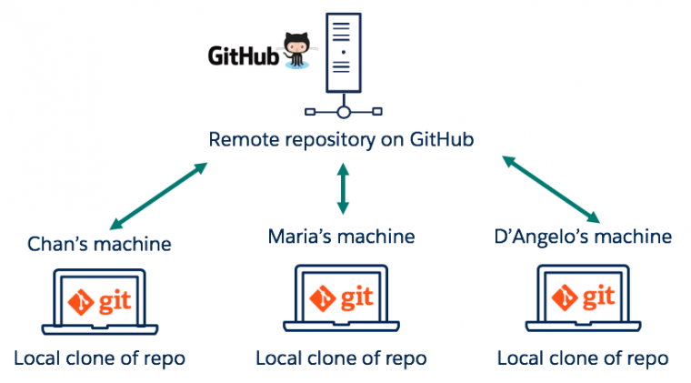

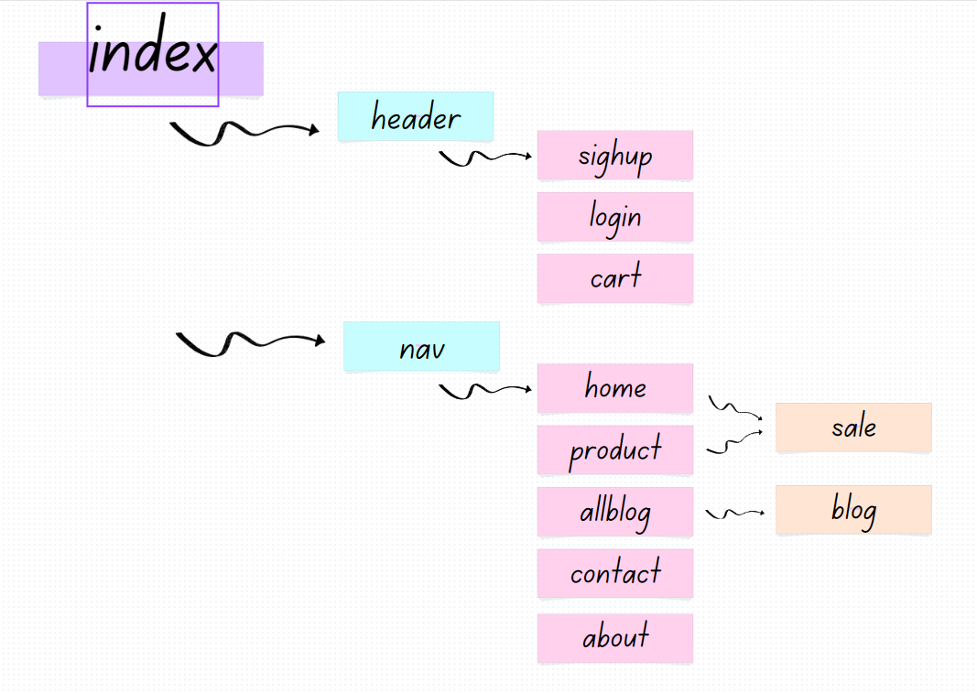

**SCREEN SHOT**

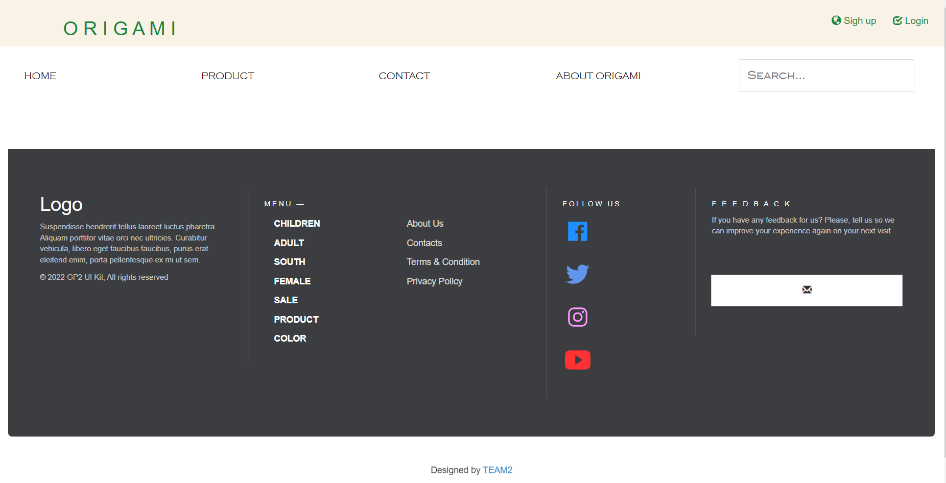

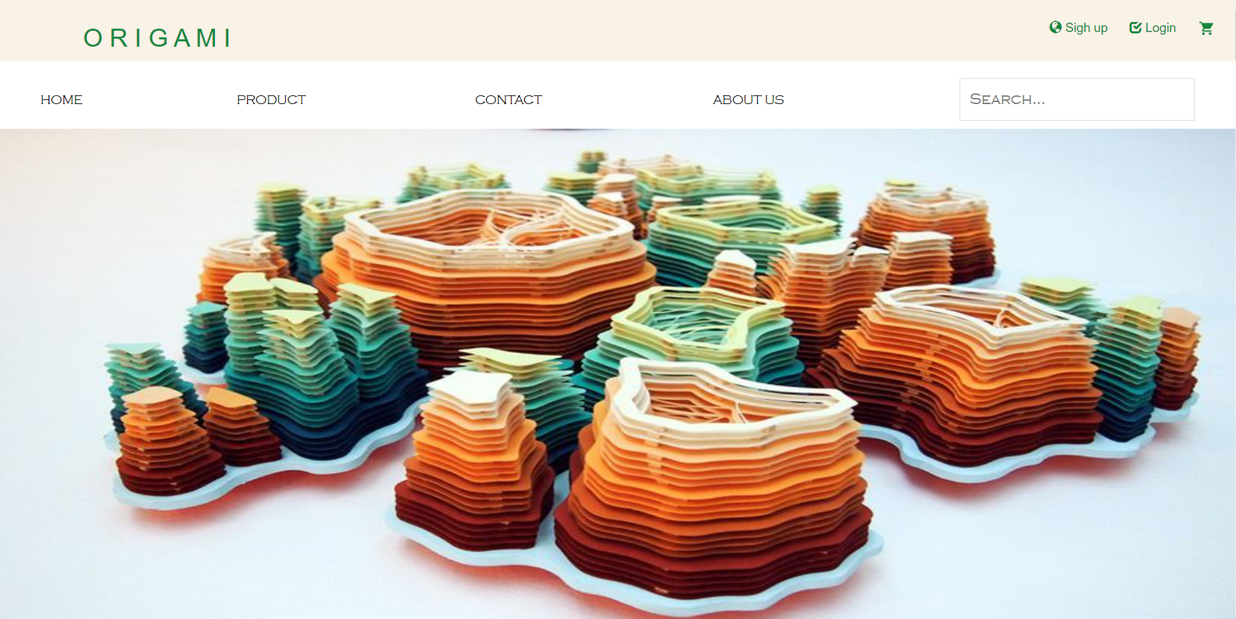

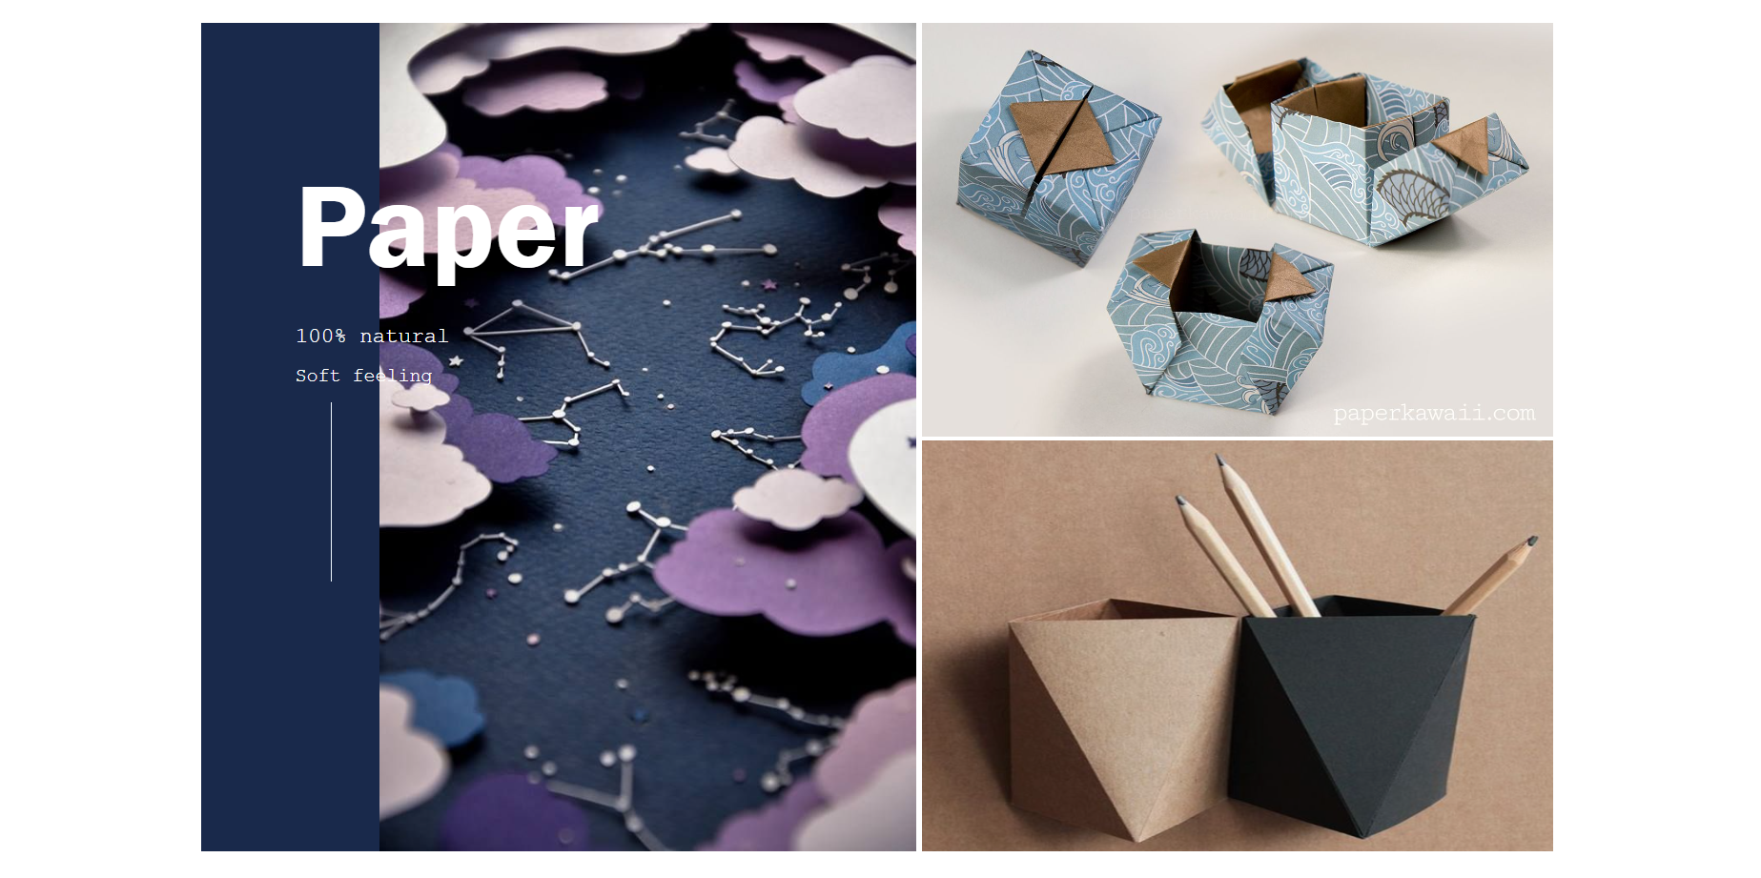

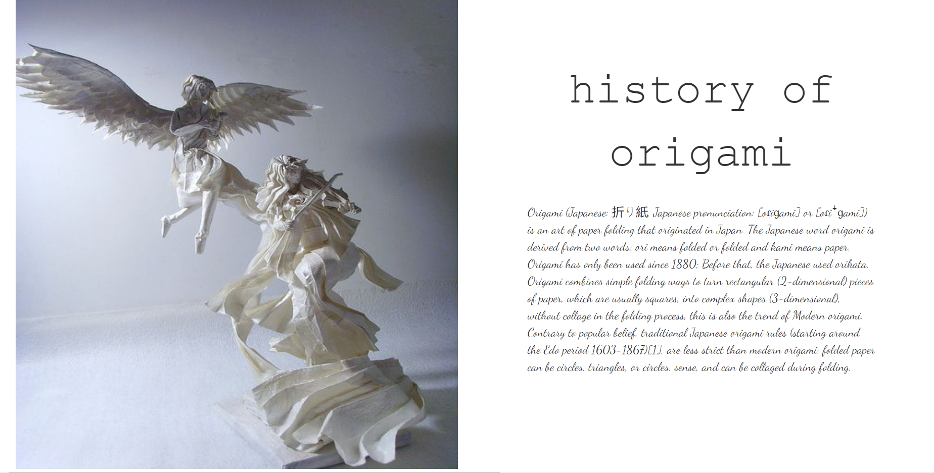

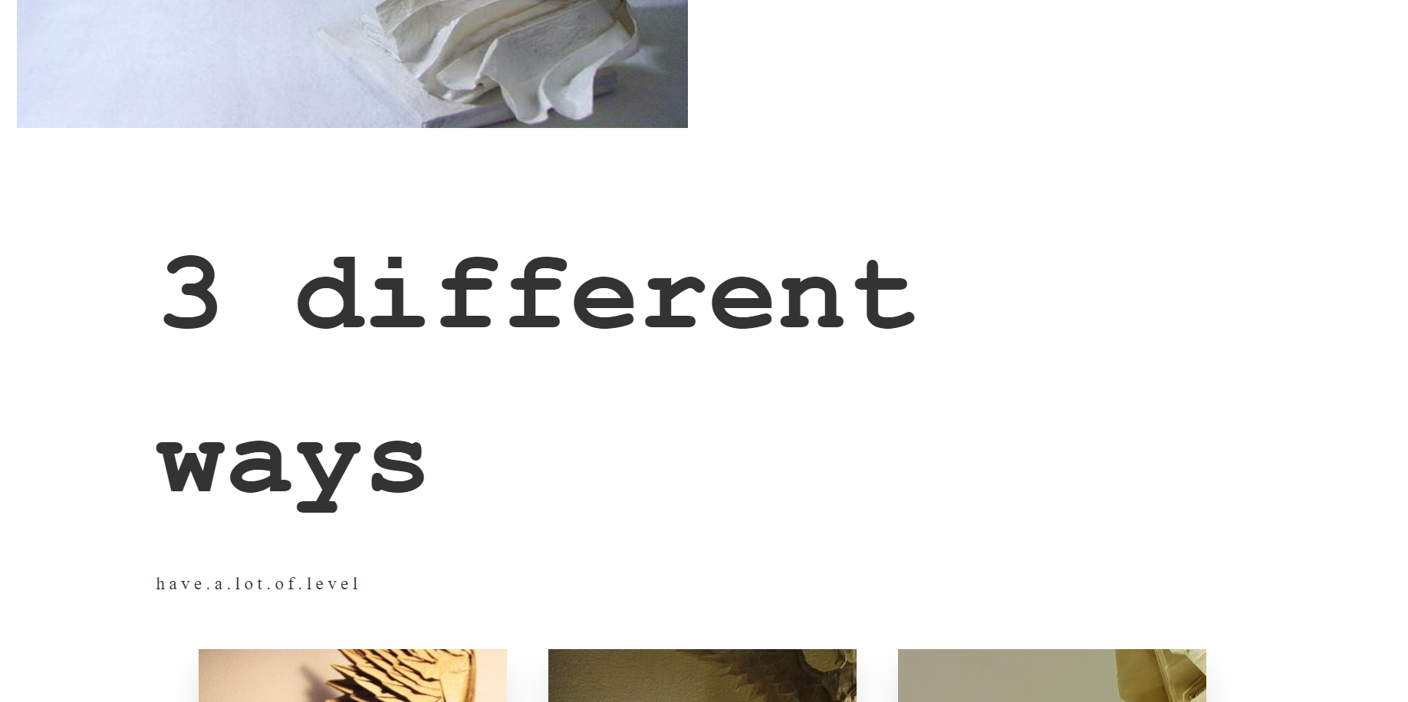

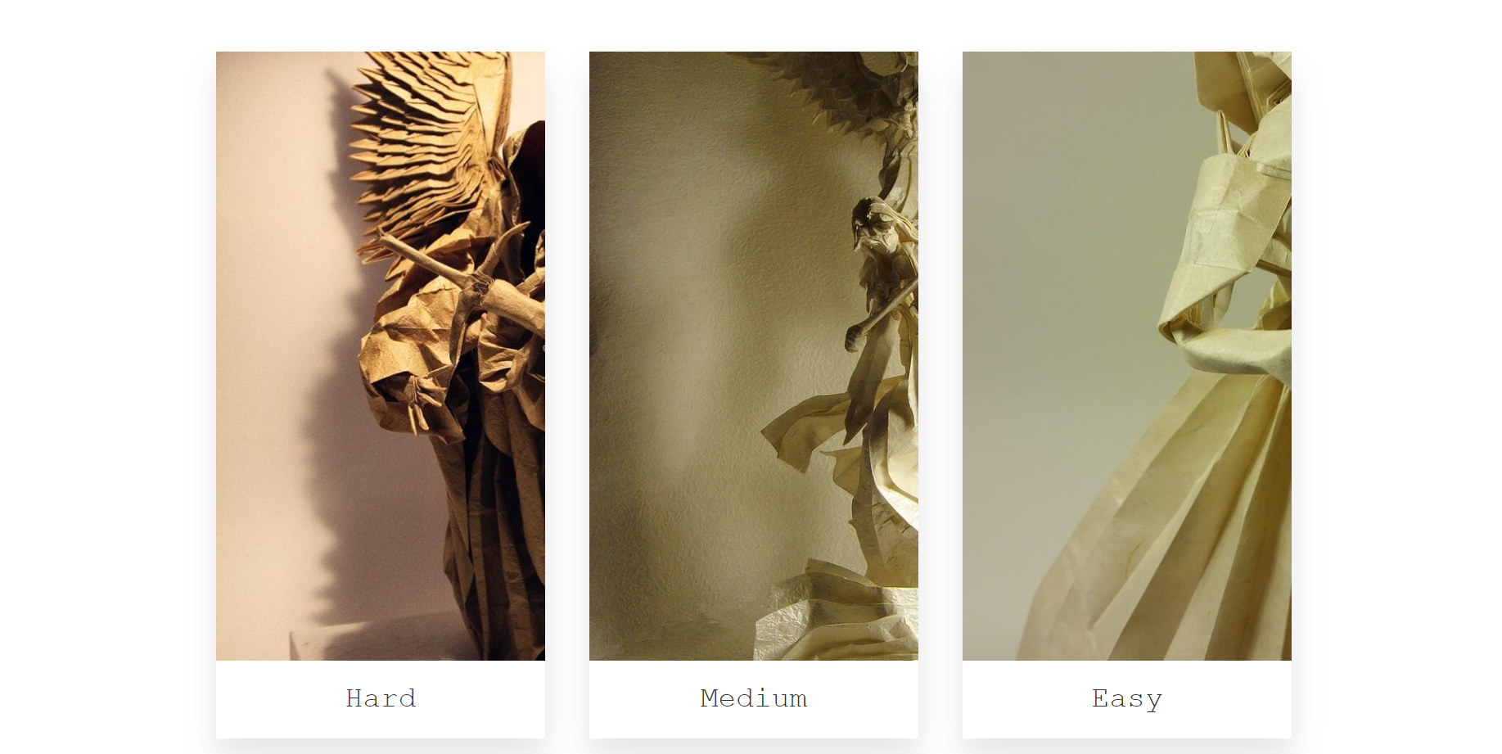



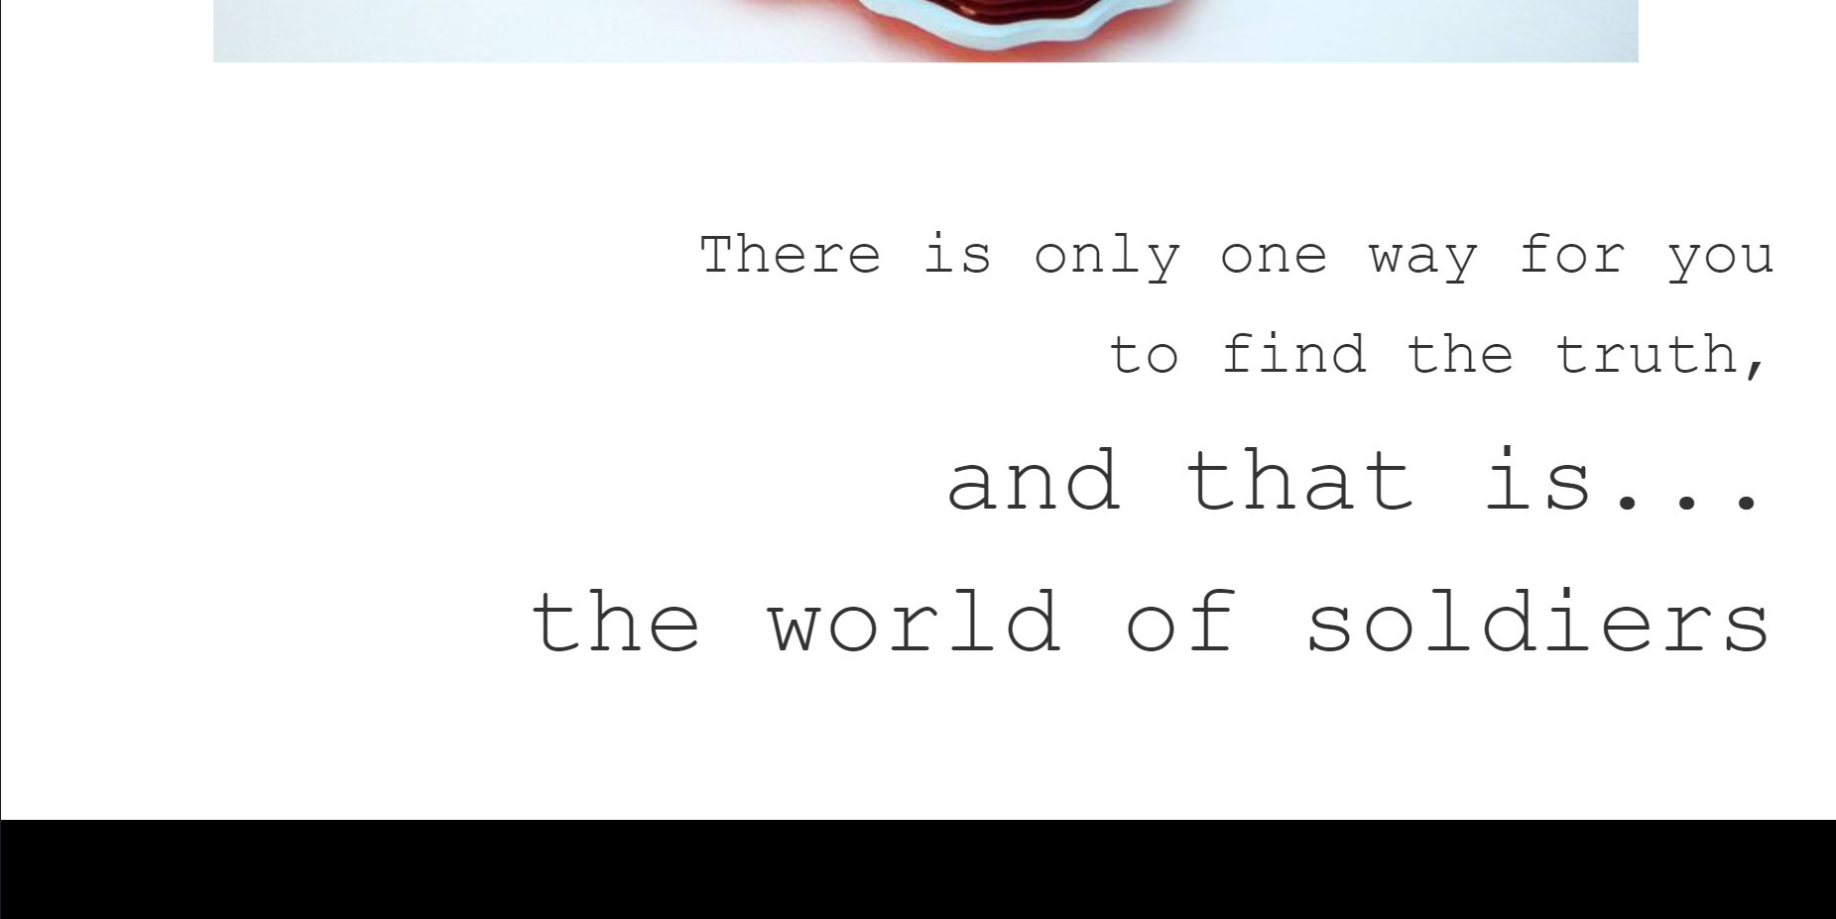



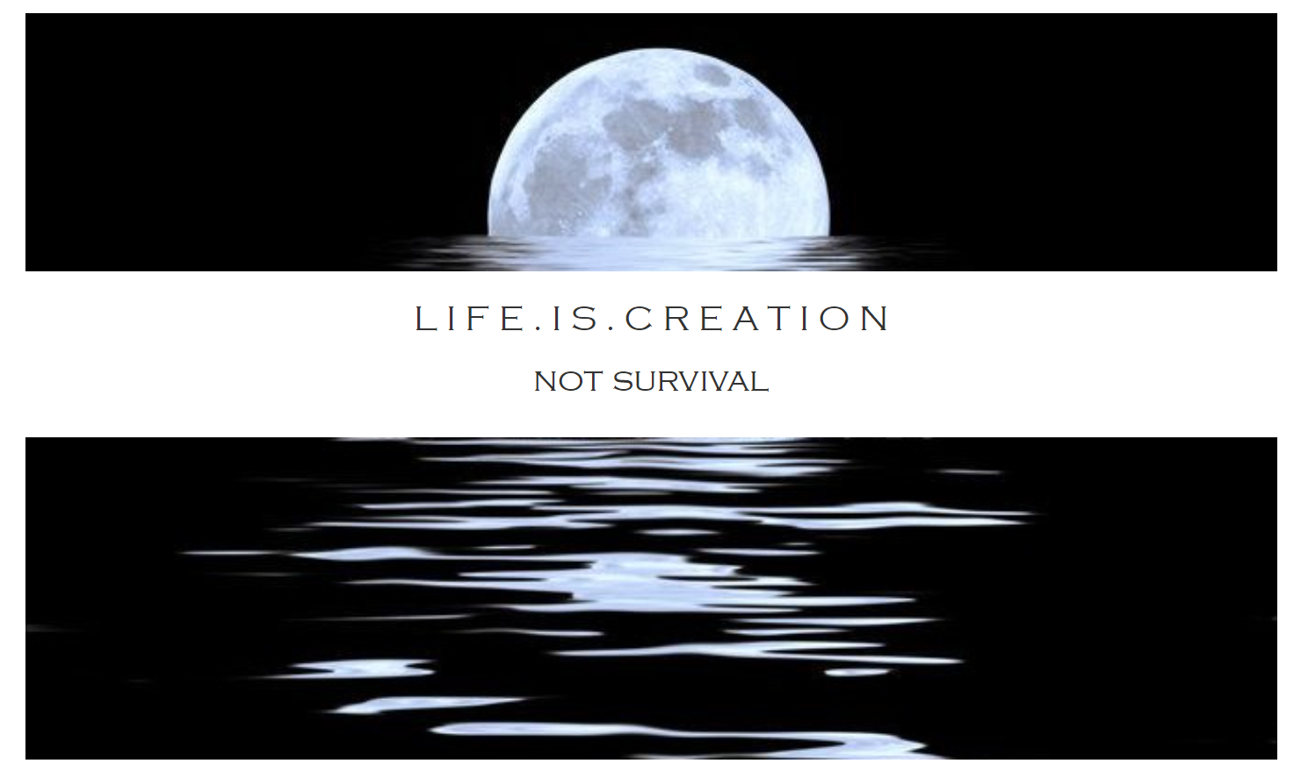

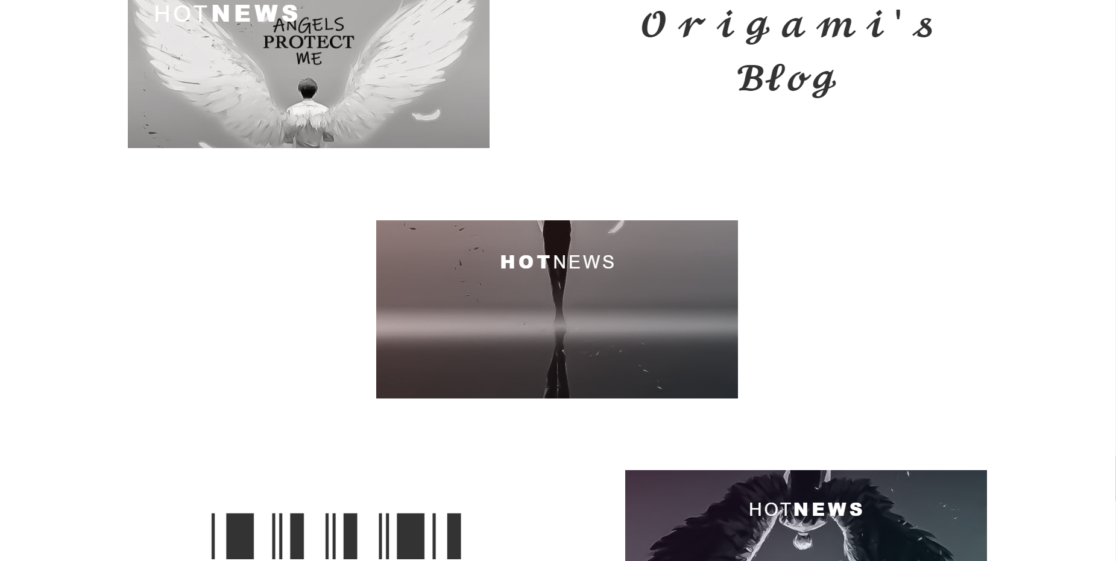

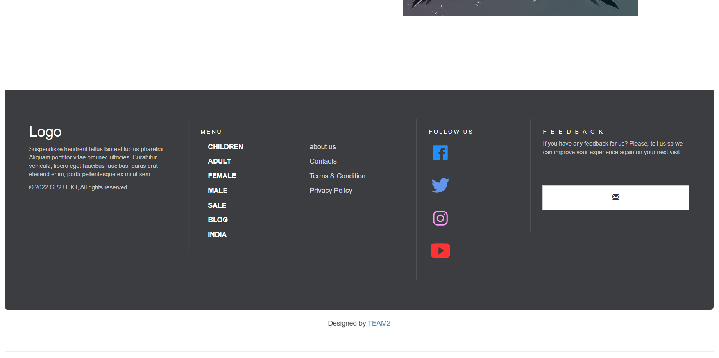

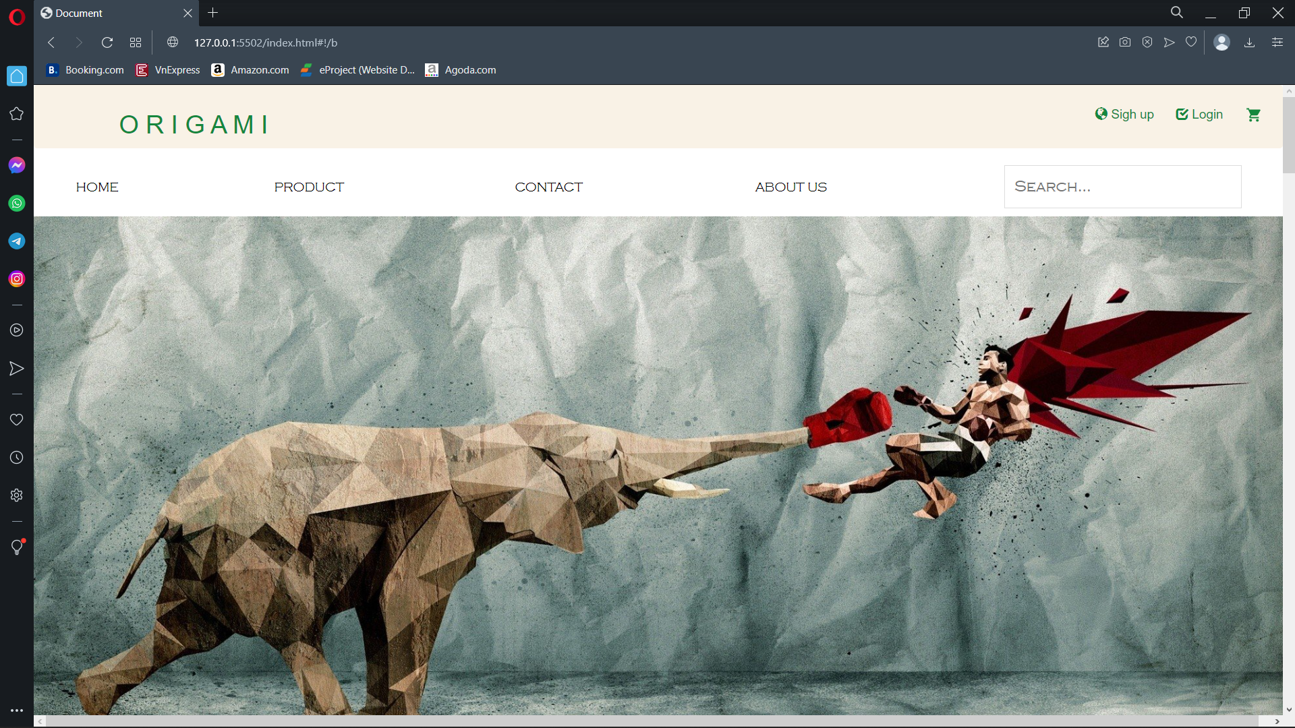

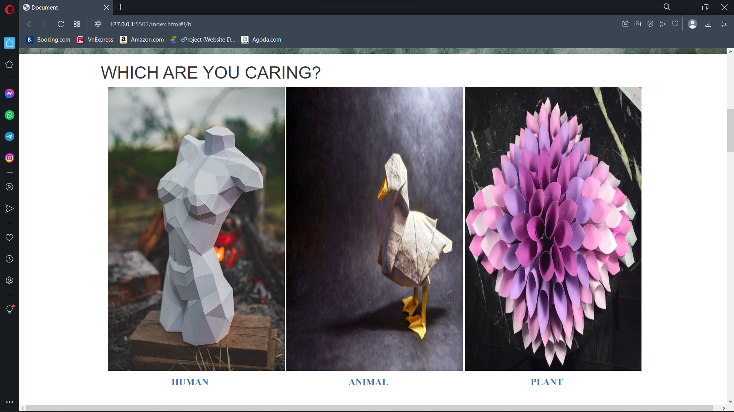

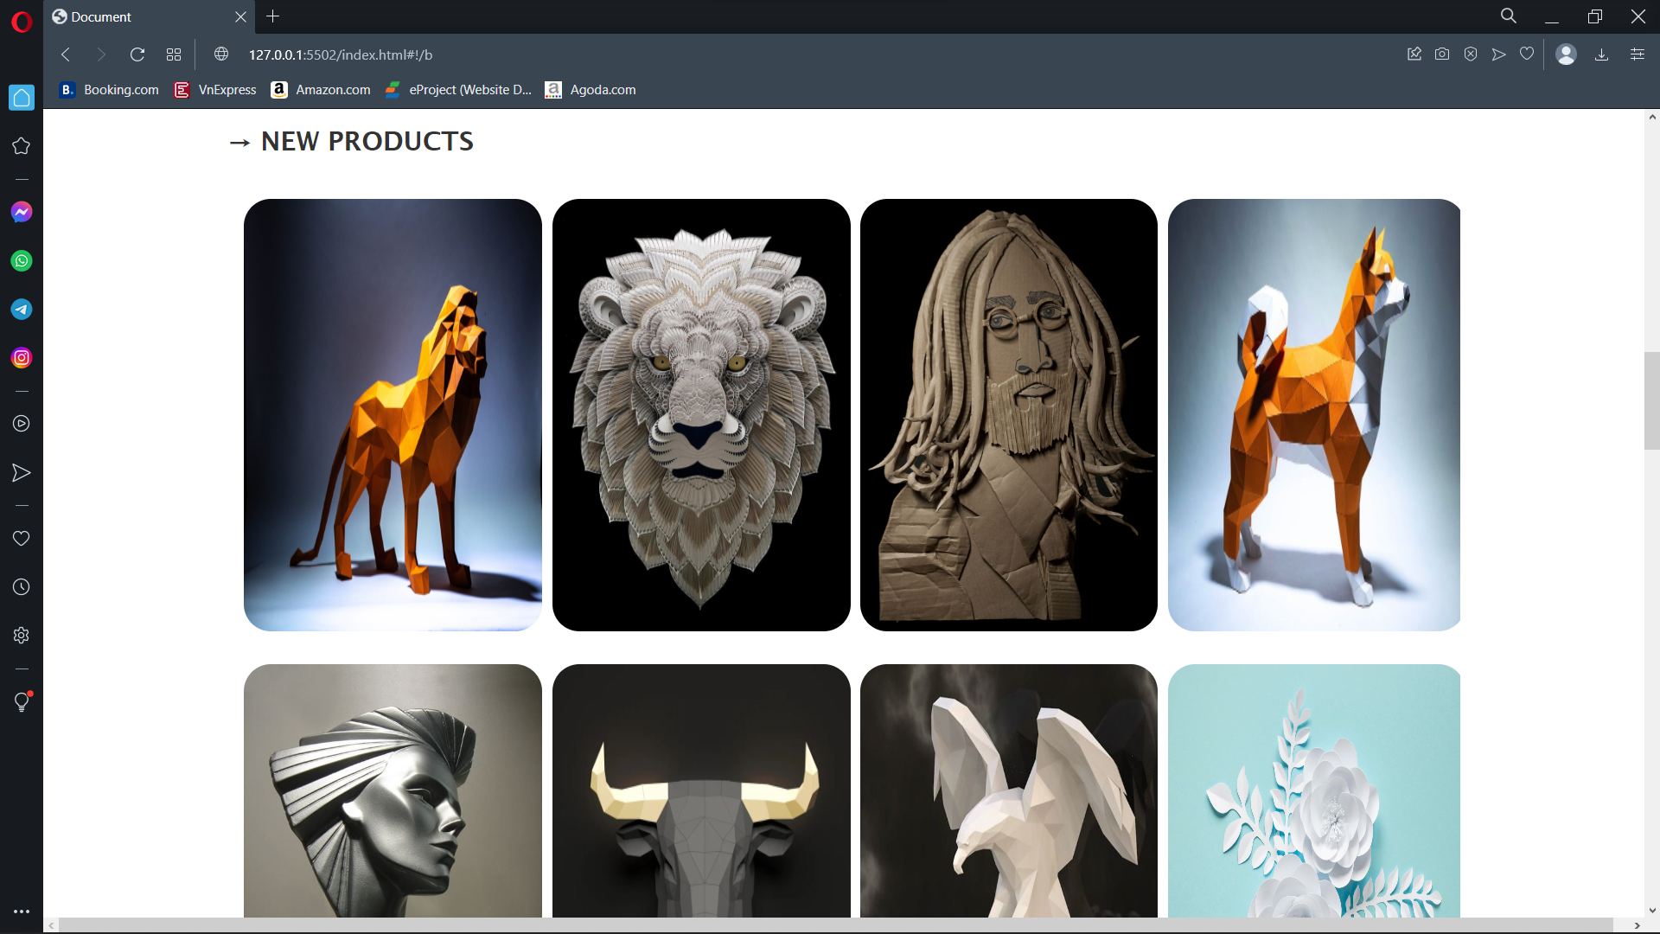

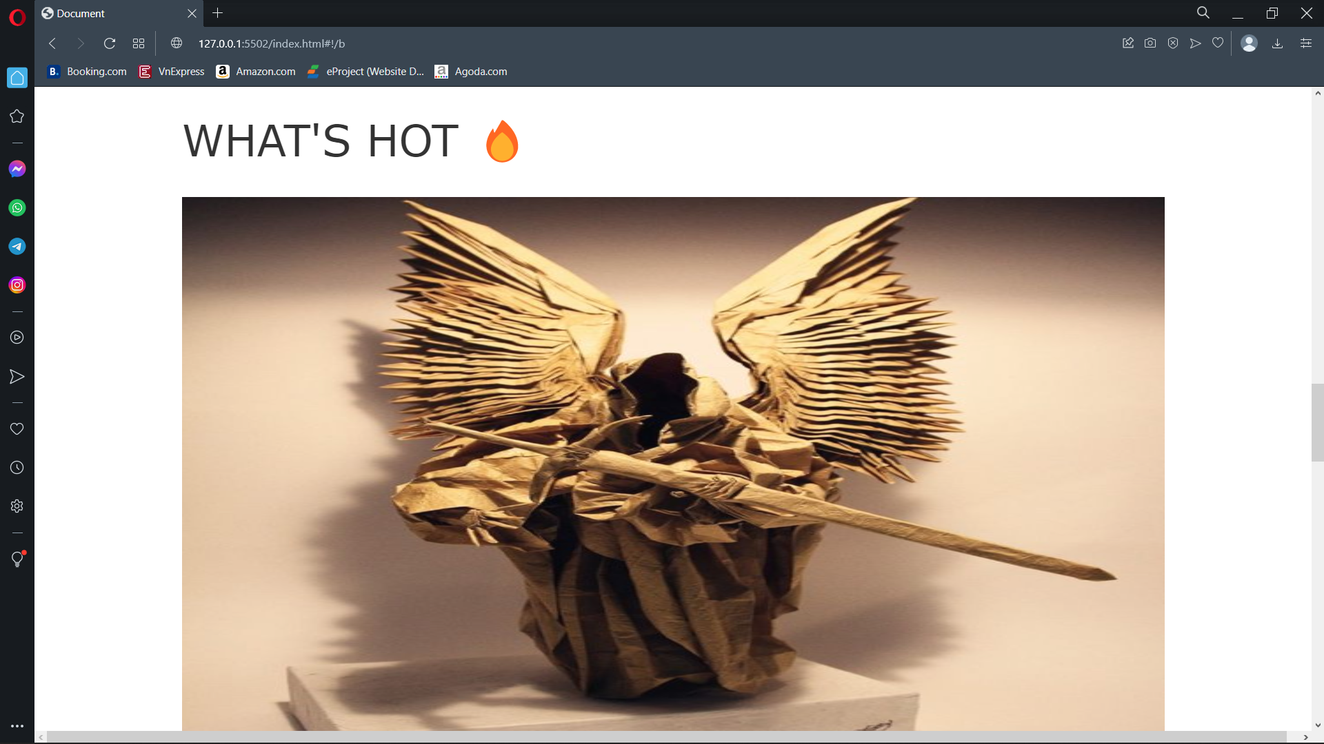

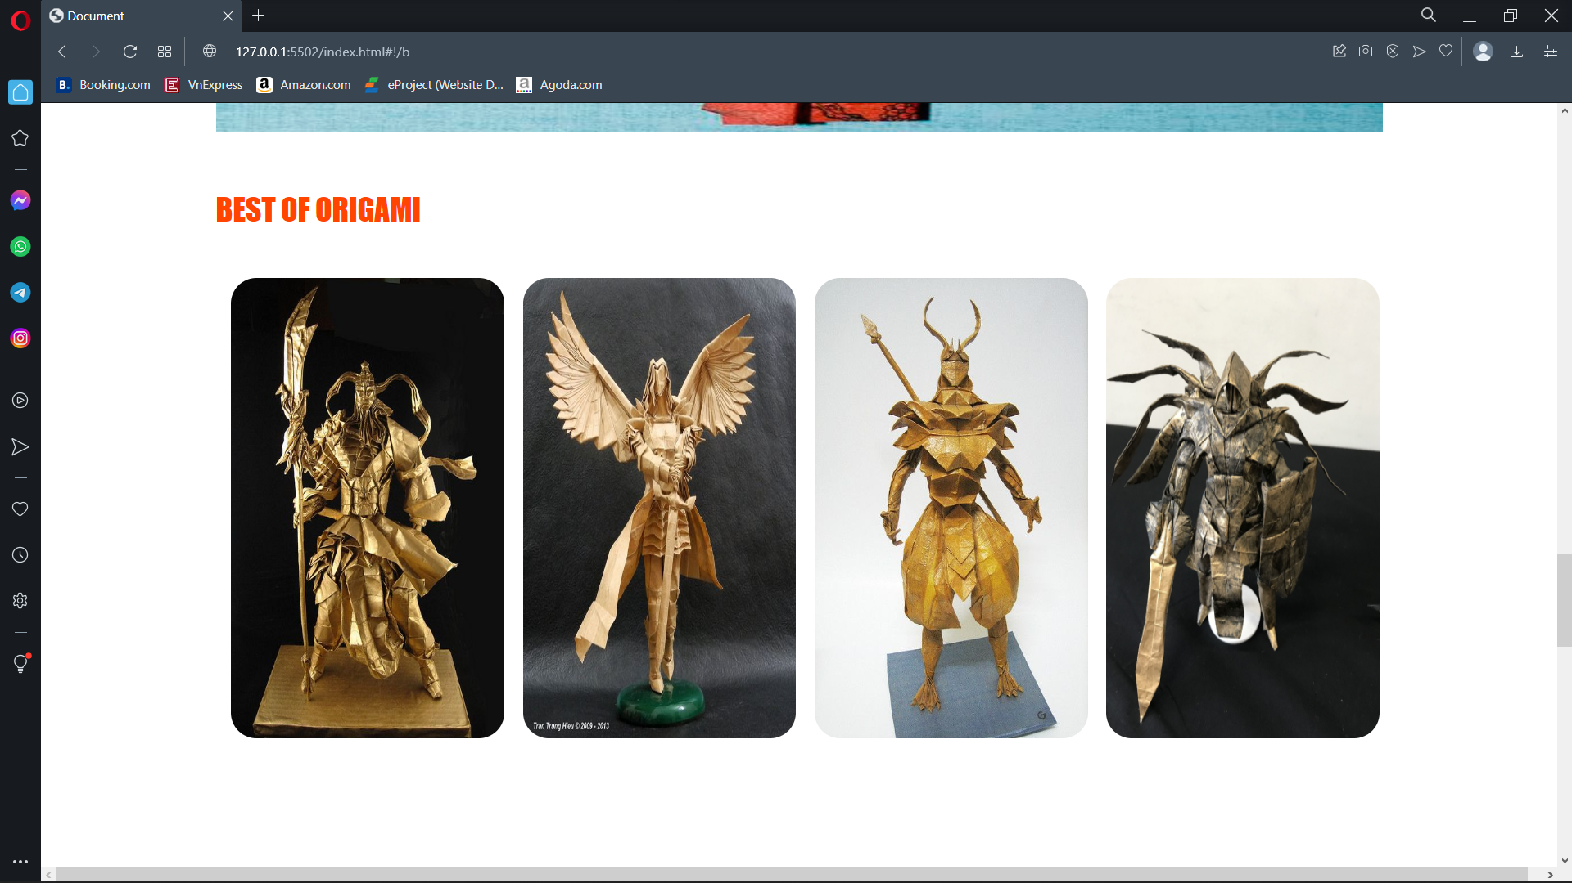

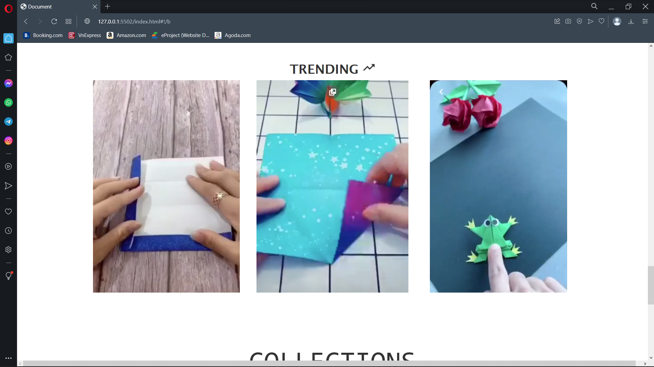

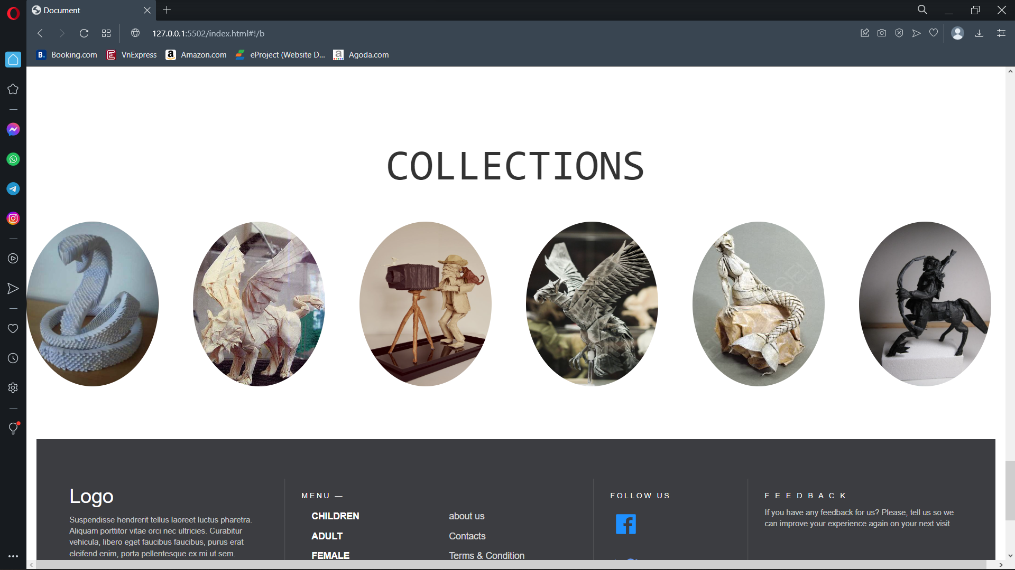

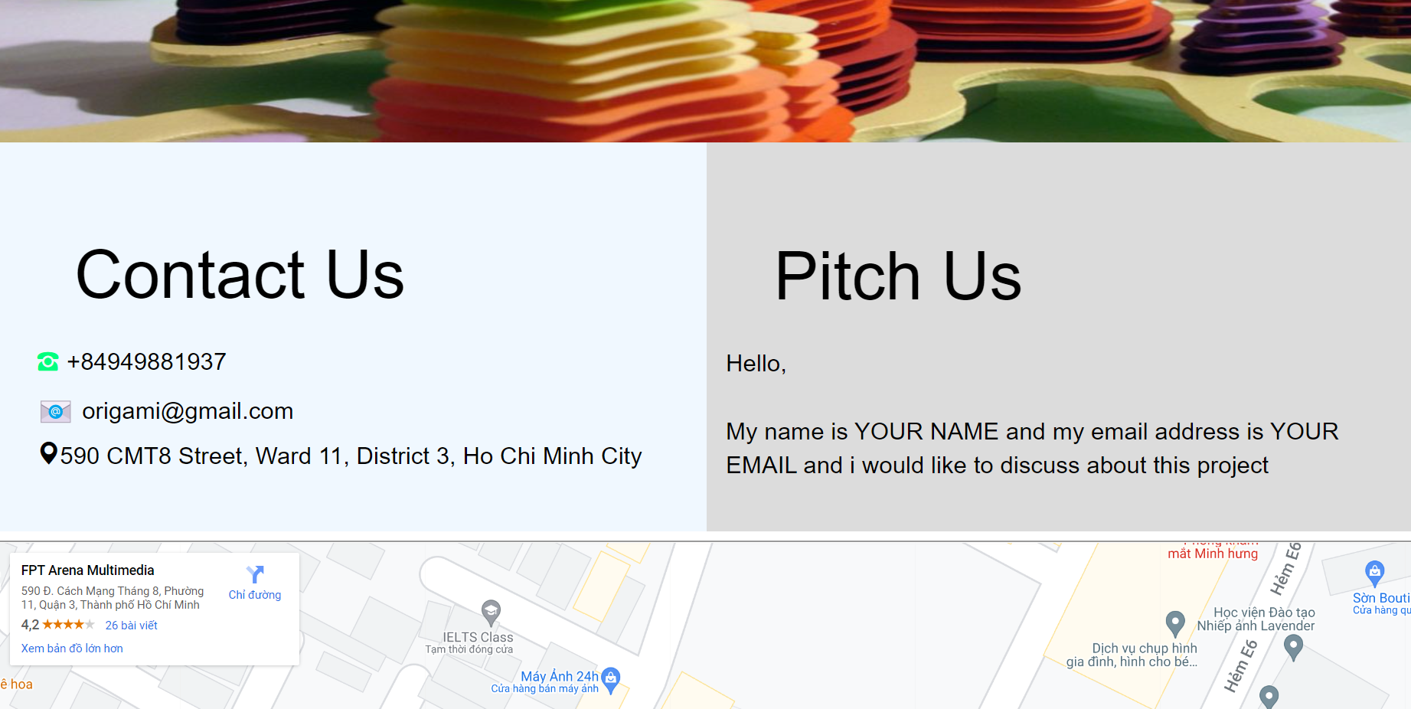

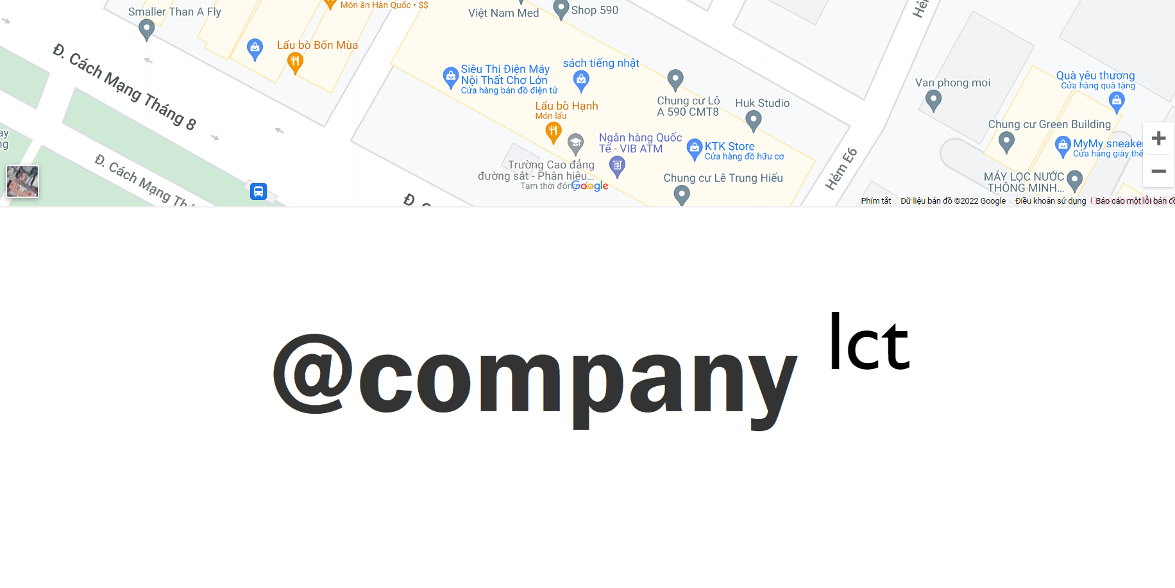

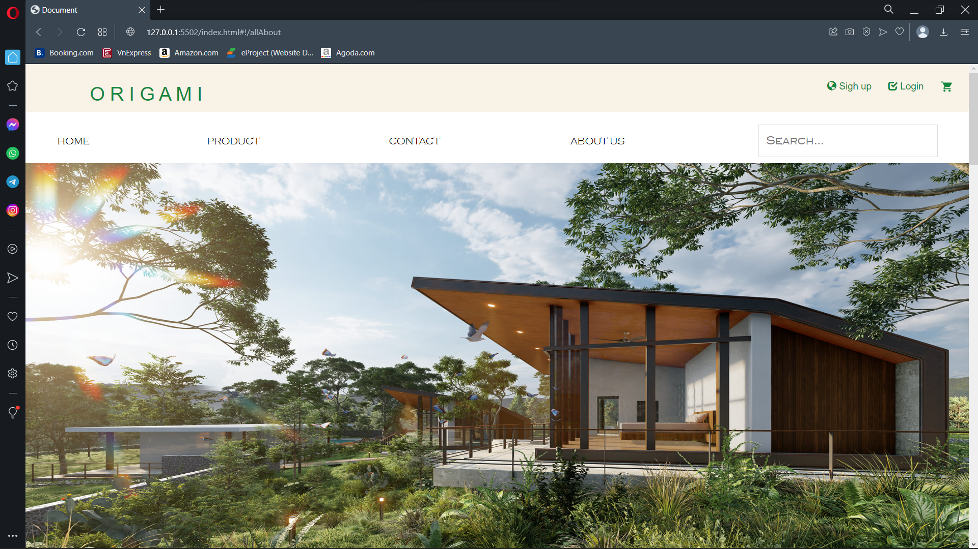

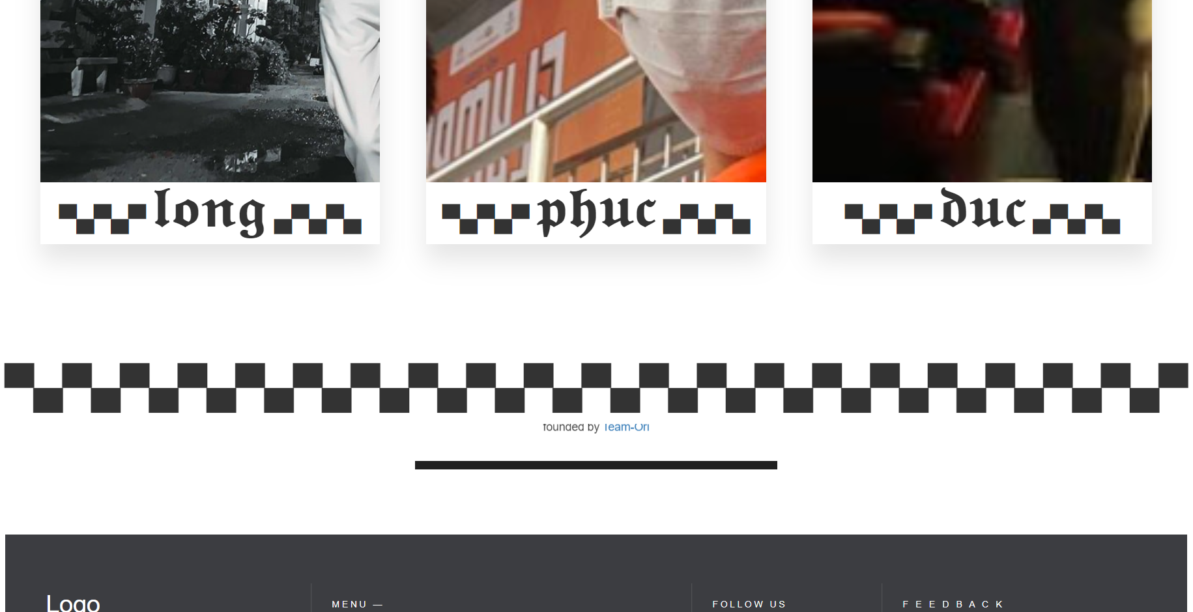

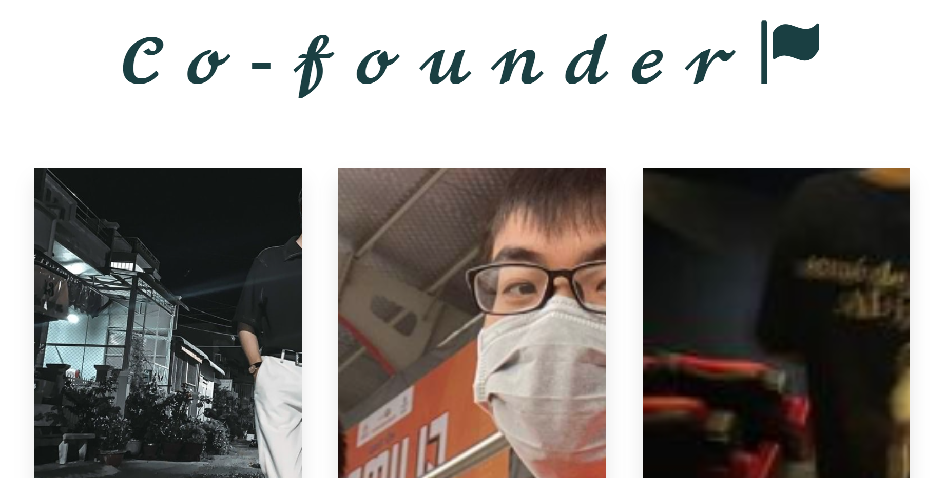

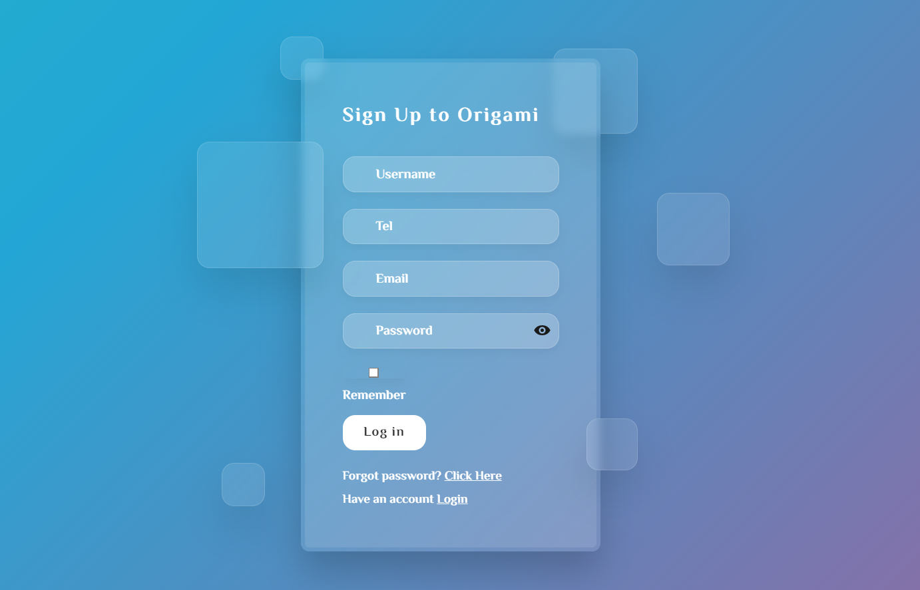

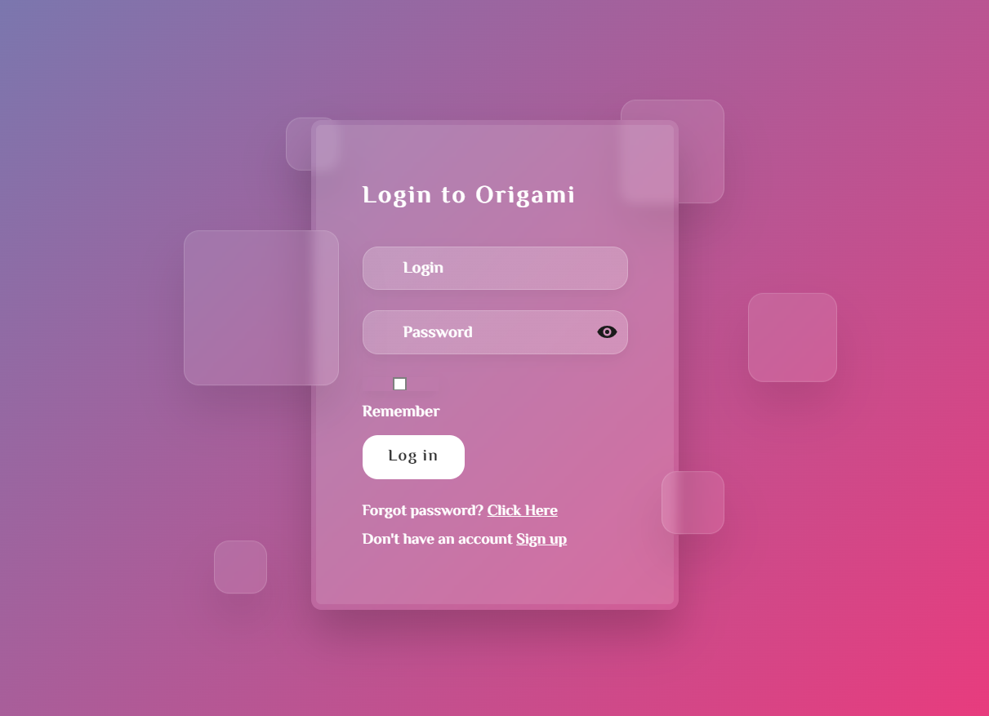

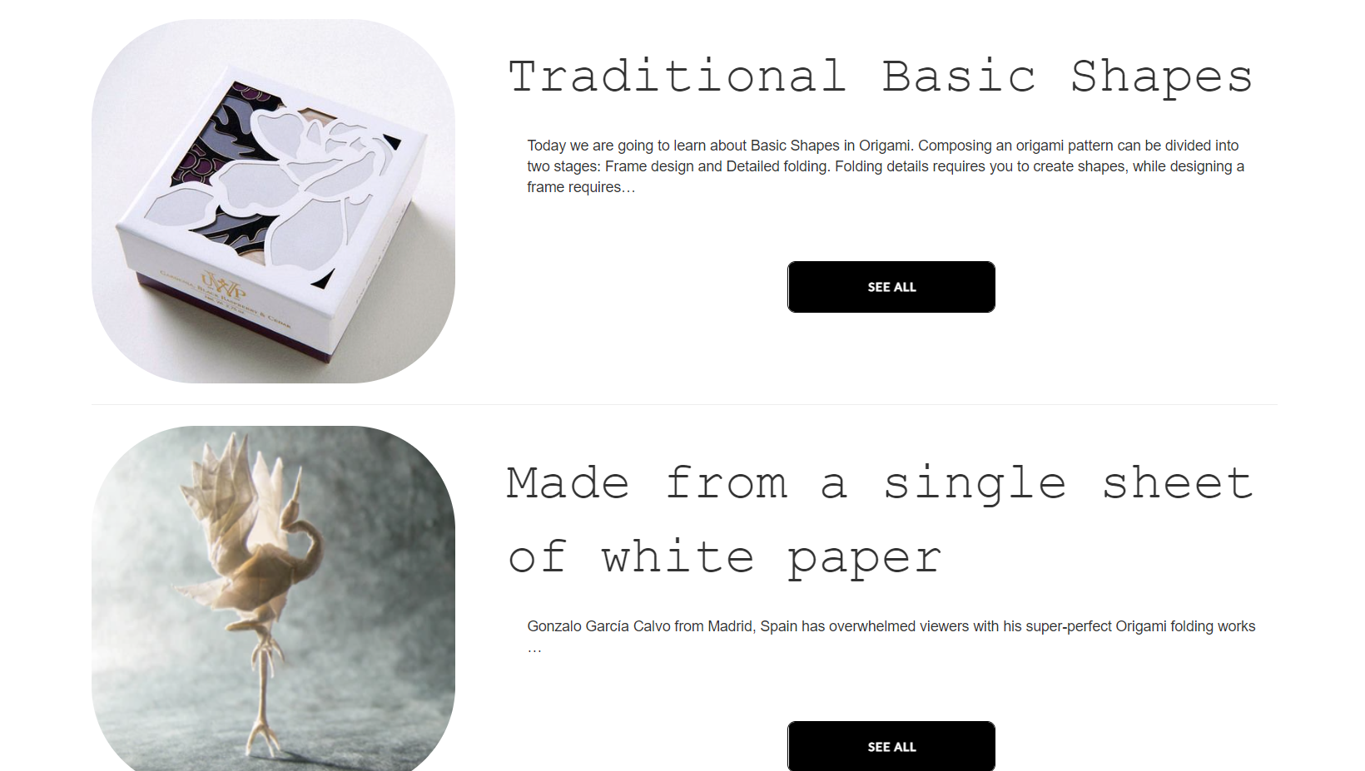

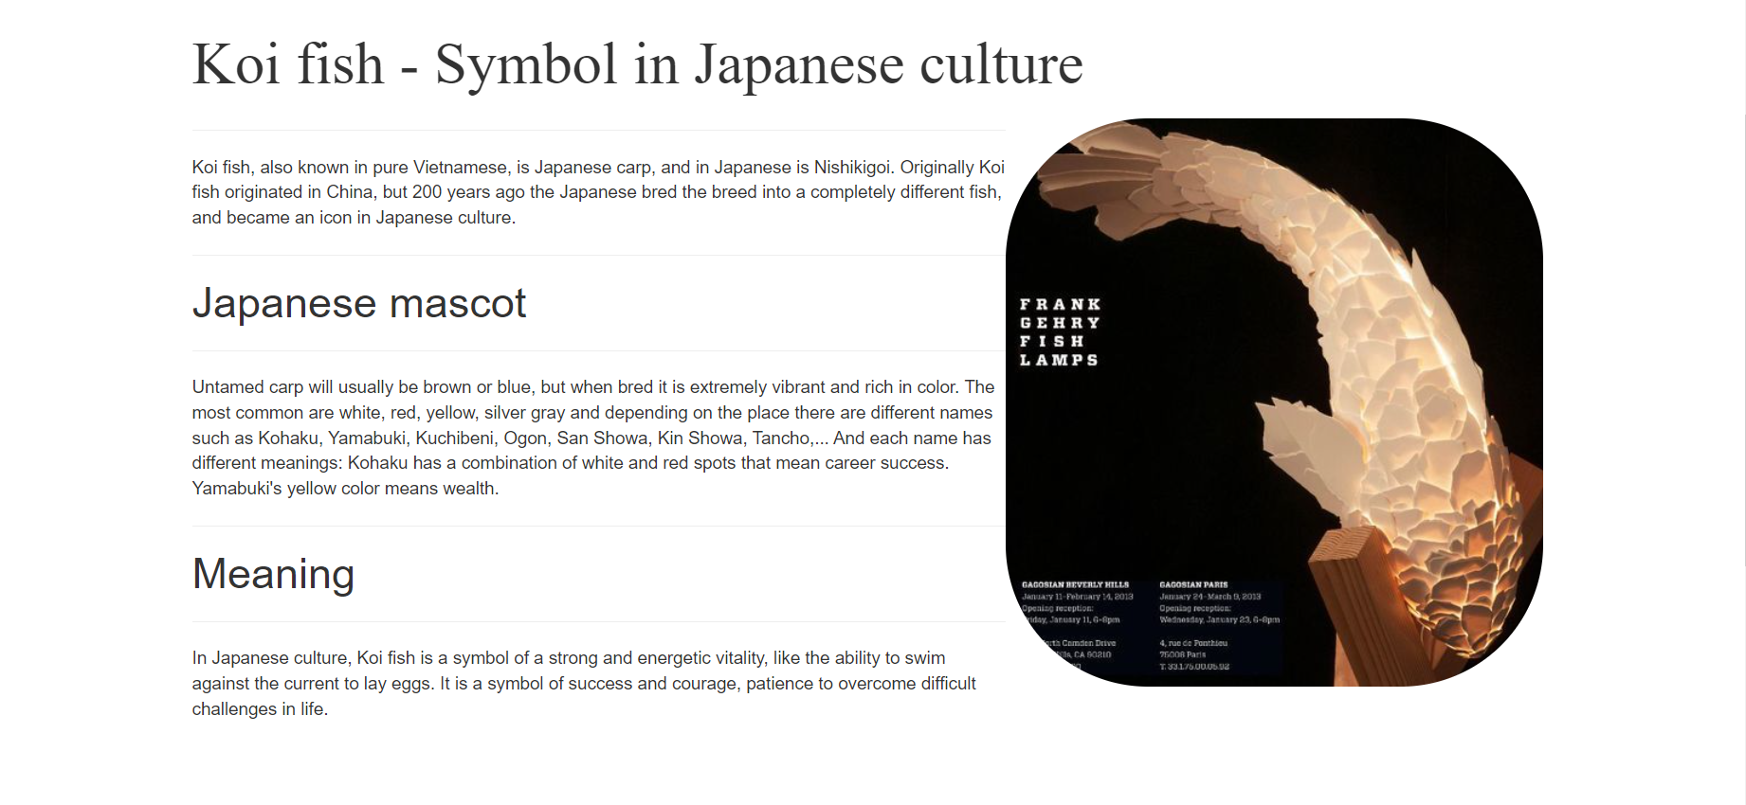

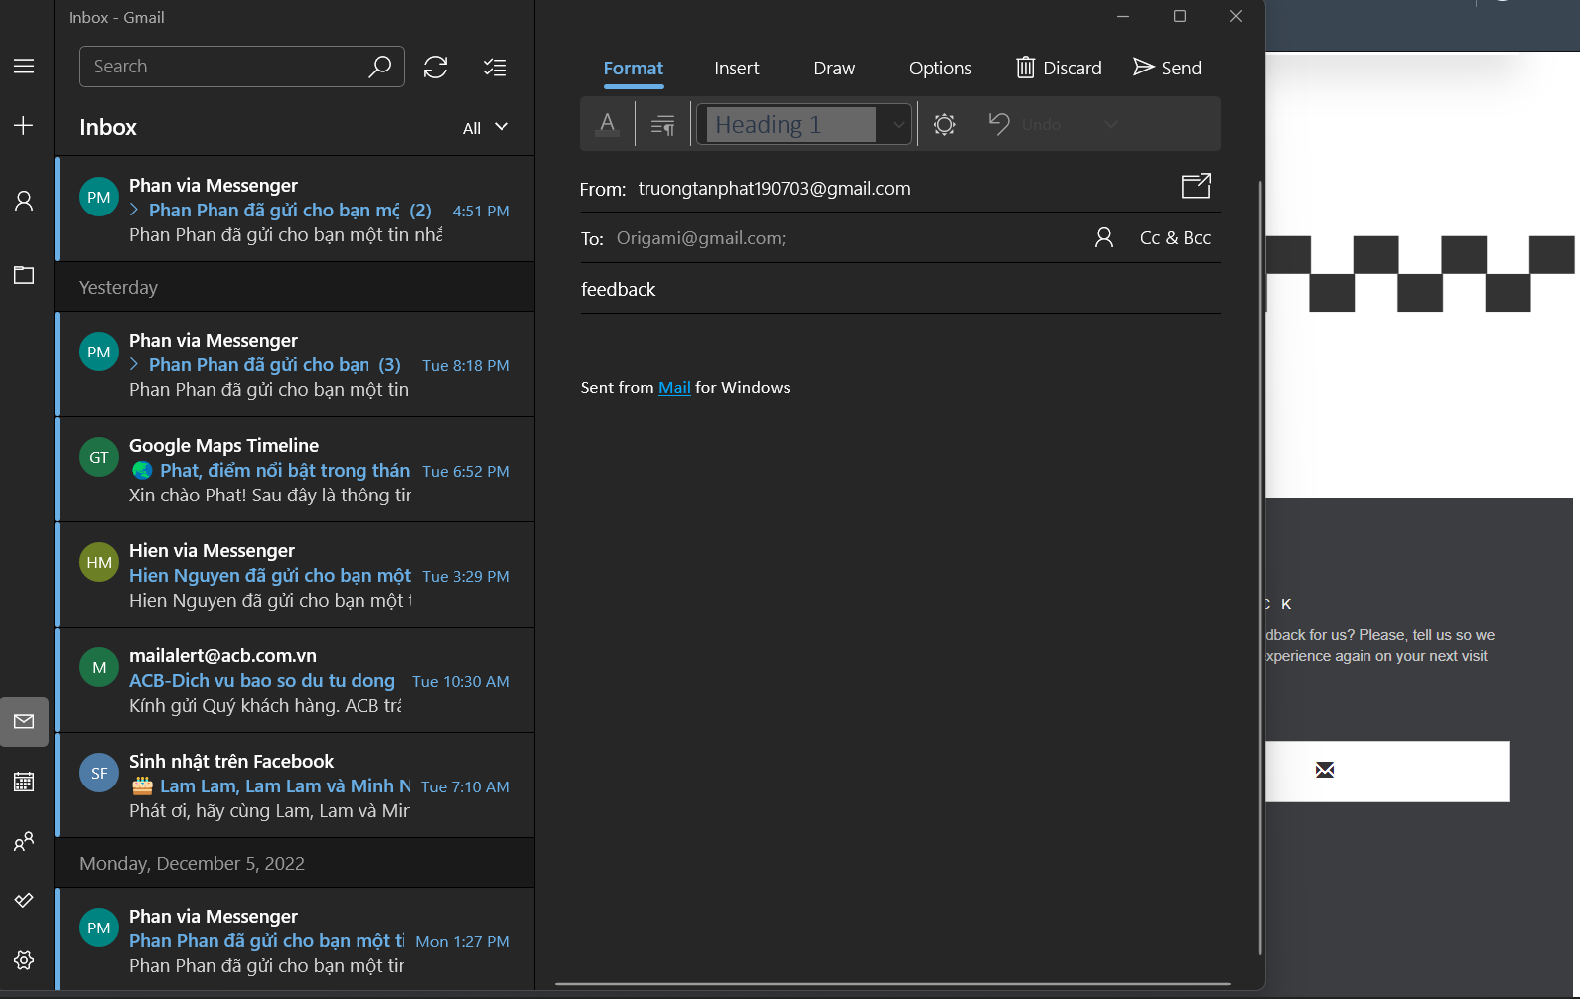

|  |  |  |  |  |  |  |  |
| --- | --- | --- | --- | --- | --- | --- | --- |
| **Member** | **Content** | **Page Name** | **Page completion level** | **Activity Plan** | **Planned Start Date** | **Actual Start Date** | **Actual End**  **Date** |
| TRƯƠNG TẤN PHÁT (leader) | Origami | index.html (header) | 100% | 1 week before starting eProject | 7/11/2022 | 7/11/22 | 9/12/22 |
| index.html (footer > feedback > mail) |
| folfer: about > allAbout.html |
| folfer: content > folfer: animal |
| folfer: content > folfer: singleProduct |
| folfer: document |
| folfer: home > allBlog.html |
| folfer: home > allBlog2.html |
| folfer: home > blog.html |
| folfer: home > home.html |
|  |  |  |
| Nguyễn Hoàng Gia Phúc | folfer: content > folfer: plant | 98% | when the project started | | 14/11/22 | 7/12/22 |
| folfer: content > folfer: human |
| folfer: product > animal.html |
| folfer: product > human.html |
| folfer: product > plant.html |
| folfer: product > sale.html |
| index.html (nav,footer) |
| /* button change page 1 & 2 */ |
|  |  |  |
| Nguyễn Trọng Tiến Đức | folfer: header > contactUs.html | 100% | when the project started | | 14/11/22 | 7/12/22 |
| folfer: pay > pay.html |
| login.html |
| signup.html |
| tym.html |
|  |  |  |
| Diệp Thái Thiên Long | folfer: content > folfer: luxury | 95% | when the project started | | 14/11/22 | 7/12/22 |
| folfer: content > folfer: cart |
| folfer: product > aboutUs.html |
| folfer: product > aboutUs2.html |
| folfer: product > aboutUs3.html |
| folfer: product > aboutUs4.html |
| folfer: product > Duc.html |
| folfer: product > Phat.html |
| folfer: product > Phat.html |
| folfer: product > Phuc.html |
| folfer: product > sale.DTTL.html |